Exceptions:

**Throw:**

**Code:**

package exceptions;

public class exceptions

{

public static void main(String[] args)

{

int a=15,b=0,rs;

try

{

if(b==0)

throw(new ArithmeticException("Can't be divided by zero."));

else

{

rs = a / b;

System.out.print("\n\tThe result is : " + rs);

}

}

catch(ArithmeticException Ex)

{

System.out.print("\n\tError : " + Ex.getMessage());

}

System.out.print("\n\tEnd of program.");

}

}

**Output:**

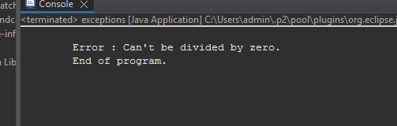

**Throws:**

**Code:**

package exceptions;

public class exceptions

{

void Division() throws ArithmeticException

{

int a=45,b=0,rs;

rs = a / b;

System.out.print("\n\tThe result is : " + rs);

}

public static void main(String[] args)

{

exceptions T = new exceptions();

try

{

T.Division();

}

catch(ArithmeticException Ex)

{

System.out.print("\n\tError : " + Ex.getMessage());

}

System.out.print("\n\tEnd of program.");

}

}

**Output:**

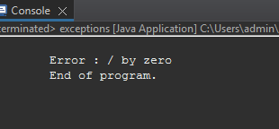

**Finally:**

**Code:**

package exceptions;

public class exceptions

{

public static void main(String[] args)

{

int a=15,b=0,rs=0;

try

{

rs = a / b;

}

catch(ArithmeticException Ex)

{

System.out.print("\n\tError : " + Ex.getMessage());

}

finally

{

System.out.print("\n\tThe result is : " + rs);

}

}

}

**Output:**

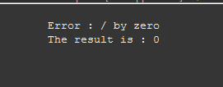

**Custom Exceptions:**

**Code:**

class MyException extends Exception

{

public MyException(String s)

{

super(s);

}

}

public class Main

{

public static void main(String args[])

{

try

{

throw new MyException("temp");

}

catch (MyException ex)

{

System.out.println("Caught");

System.out.println(ex.getMessage());

}

}

}

**Output:**

